SOFTWARE PROJECT PLAN
Julie White (2832202)
1.0 Introduction
The project will consist of a food tracker for a household called TastyTracker. The software will keep track of the type/quantity of food in a household, offer an adjustable grocery list, and access to recipes.
1.1 Project scope
This software will keep track of what food and ingredients are in a user’s fridge or pantry, and the quantity of those items can be increased or decreased as changes occur. When the user decides they are running low on an item, they may add that item to a shopping list. The user can also find recipes based on the items in their household or recipes they would like to make and add missing items to their shopping list.
Major Inputs: Username and password, food items in the household, the quantity of those items, and items wanted on the shopping list.
Processing functionality: update food/ingredient quantities, identify missing ingredients from recipes, maintain a shopping list, and filter recipes based on available ingredients.
Outputs: Overview of food in the household, shopping list, identification of items missing from a recipe, and recipes that can be made given the current food in the household.
1.2 Major software functions
- Inventory Management
  - Add, edit, or delete items in the fridge/pantry
  - Adjust quantities of items as they are used or replenished
- Shopping List Creation
  - Ability to add items to a shopping list when quantities run low
  - Add items to the shopping list when not in inventory and are included in the recipe to make
  - Remove purchased items from the shopping list
- Recipe Search and Management
  - Search for recipes based on available ingredients
  - Find recipes to make and identify missing ingredients
- Data Synchronization
  - Allow multiple users to edit a household’s inventory
  - Sync data across devices
1.3 Performance/Behavior Issues
- Must take special consideration to avoid race conditions created by multiple users editing an inventory simultaneously
- Software must perform efficiently when accessing multiple databases
- The speed at which recipes are returned could be negatively affected by large inventories.
1.4 Management and Technical Constraints
- Resource constraints: Limited development team (1 developer). I work a full-time job, so my time is limited, and my ability to work with a team is negatively impacted by the time spent there.
- Technical constraints: Must be compatible with either Android or iOS. If time permits, compatibility with both would be ideal.
- Deadline: I will follow the deadlines presented in the class schedule, with the initial version being due 11/14 and the “drop dead” date being 12/5
2.0 Risk Management
2.1 Project Risks
- Too large of scope. This project is meant to be completed by the end of the semester, so overextending would be detrimental to the app's success.
- The delivery deadline being tightened. Although this is not very likely, it would still be detrimental to the project's success.
- Requirement change—Changing the requirements for any reason could interfere with the ability to meet the deadline.
- Technology change- having to change the operating system, language, or database could severely affect the ability to meet the deadline
- Less Reuse than planned—I have made a very basic app that shares some of the same principles. It would be helpful if I could reuse some of this application frame.
- Inexperience—not having enough knowledge of how to build the app would be problematic, as time would have to be spent learning rather than building.

2.2 Risk Table
Risk | Probability | Impact | Mitigation
Delivery Deadline Tightened | 10% | 1 | Risk Information Sheet 1- page 8
Too Large of Scope | 50% | 2 | Risk Information Sheet 2- page 9
Requirement Change | 60% | 2 | Risk Information Sheet 3- page 10
Technology Change | 70% | 2 | Risk Information Sheet 4- page 11
Less Reuse than Planned | 40% | 4 | Risk Information Sheet 5- page 12
Inexperience | 20% | 2 | Risk Information Sheet 6- page 13
    - Catastrophic
    - Critical
    - Marginal
    - Negligible
2.3 Overview of Risk Mitigation, Monitoring, Management (RM3)
The project faces several potential risks that could impact the timeline and ultimate success of the software. Each risk, whether high, medium, or low impact, can negatively affect the success of the software. Due to this, close monitoring and mitigation is pivotal to risk management. High risks for this project include a scope that is too large, requirement changes, and technology changes. There is only one medium risk: the delivery deadline being tightened. Low risks to the project are as follows—less reuse than planned and inexperience. Mitigation strategies such as scope control, technology monitoring, and regular reviews should help keep the project on track for successful completion by the deadline. The mitigation strategies for each risk are explained fully in the Risk Information Sheets attached to the end of this plan.

3.0 Project Schedule
This section presents an overview of project tasks and the output of a project scheduling tool.
3.1 Project task set
I have decided to follow an agile process model to allow for iterative development and more flexibility for review and testing. Specifically, I will follow a model similar to the XP process.
This process involves:
- Select user stories for this release
- Break down stories to tasks
- Plan Release
- Develop/integrate/test software
- Release Software
- Evaluate System
The task set associated with this project is
- Initial setup
- Core functionality development
- Testing
- Recipe integration (not core functionality)
- UI Refinement
3.2 Functional decomposition
The functional breakdown is as follows:
- Set up the development area and select technologies to use.
  - Select key technologies like OS and IDE to begin the project.
- Develop a sign-in screen and implement its database.
  - Requires database to register/store user information and query that database to log in the user upon entering the correct information.
- Develop an inventory screen and implement its database.
  - Buttons, views to track food items in fridge/pantry and update quantities.
- Develop a shopping list screen and implement its database.
  - Allow users to add low-stock items to the shopping list and other items not currently in inventory.
- (Not core to functionality) Add recipe search
  - Integrate user being able to search for any recipe
- (Not core to functionality) Build a function to determine which items are missing from inventory given a recipe and create an option to add those items to the shopping list.
  - Query the database to figure out which food items are missing from the recipe.
- (Not core to functionality)Build a function to find recipes based on inventory.
  - Filter recipes to find which recipes are makeable given a current inventory.
- UI Refinement
  - Fix UI to make it more user-friendly and aesthetically pleasing
- Testing and Bug Fixes (done twice).
  - Bug testing/fixing is done twice, first after shopping list creation and again after UI Refinement.

3.3 Task network
The following pages show tasks and dependencies in a Gantt Chart. This chart was also broken down by month for a better view of the dependencies.

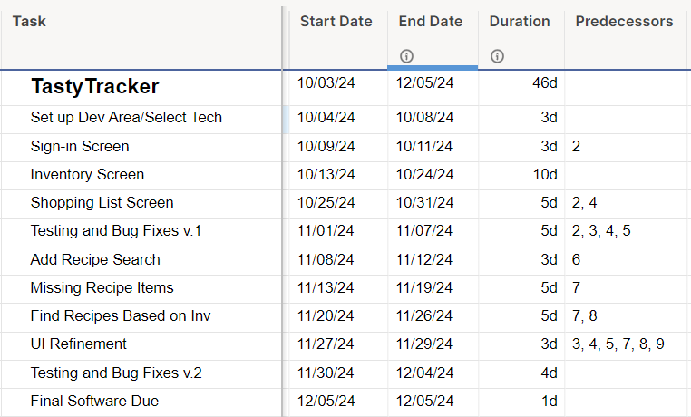
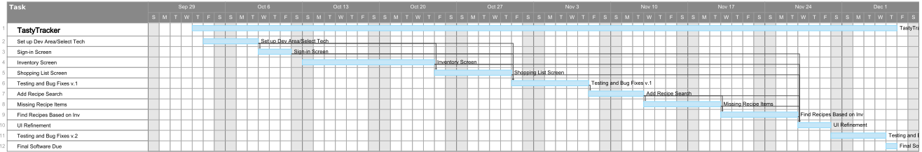
Full Gantt Chart:

Gantt Chart by Month

October 3rd to 31st:
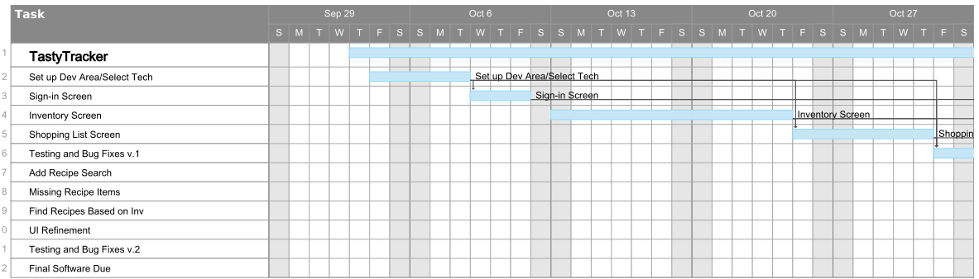
November 1st to December 5th:
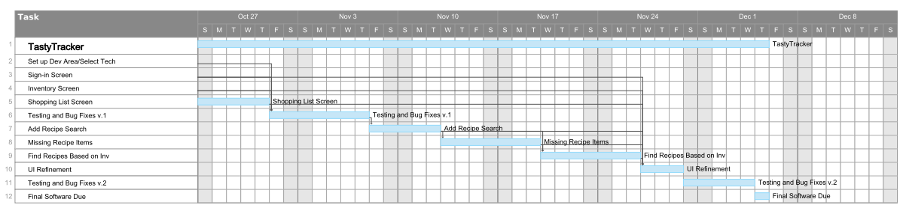

3.4 Timeline chart
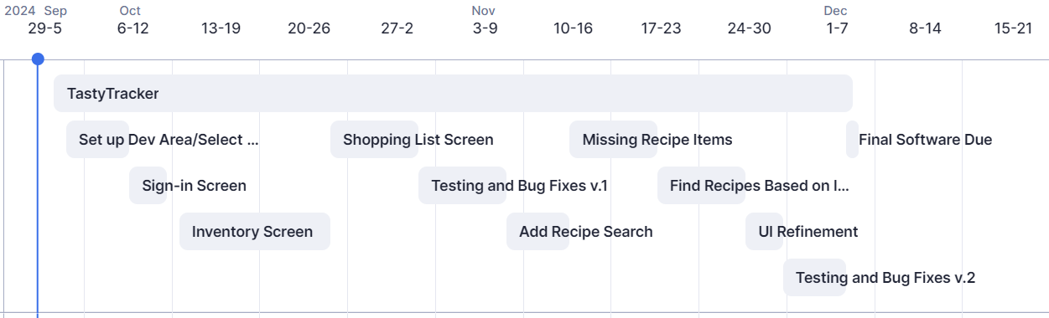
Full Timeline:

3.5 Schedule compliance
To ensure that the project stays on schedule (and is ultimately successful), a few measures will be taken to monitor progress. As the development team consists of one person, there are no other members of the team to hold each other accountable. Instead, I will use the assignments given for the project and the charts above to keep the project on schedule. The assignments serve as markers as to where the project should be in an academic context. Whereas the charts give a visual image to monitor where progress should be. I will review my progress at the end of a task's due date. If the development is behind where it should be, I will immediately and quickly change deadlines if necessary. If the progress of the software is critically affected, I will determine if a priority adjustment or scope adjustment needs to be made. I will hold myself accountable for finishing the software by monitoring progress using assignments and charts.

4.0 Appendix
All the Gantt charts and timelines were created using Smartsheet.com. To access the timeline digitally, use the link here: https://app.smartsheet.com/sheets/G9XjFMq7H6GPW835h6fHhH3XgpcVPr8V2PmXM9C1.

Risk Information Sheet
Risk: Delivery Deadline Tightened | Date: 10/3/2024 | Prob: 10% | Impact- Med
Description: Given the semester has a predefined end date, the chances of the deadline being tightened are very low. If the deadline were to be tightened, it would have a catastrophic impact on the project's success, given the small development team and predefined goals.
Refinement/Context:
Subcondition 1: The project is tied to a strict academic timeline (Cleveland State Academic calendar and semester-end date).
Subcondition 2: Any unexpected changes in the academic calendar (e.g., institutional scheduling or course disruption) could result in a shortened deadline.
Subcondition 3: The small development team has limited capacity to expedite work if the deadline is unexpectedly tightened.
Mitigation/monitoring:
- Constant conversation with the professor to confirm and maintain the deadline.
- Prioritize essential project tasks and ensure that the most critical functionality is completed first to mitigate the impact of a deadline shift.
- Create a contingency plan for expedited testing in case the deadline is unexpectedly shortened.
- Schedule buffer time in the final week of the project timeline for unforeseen issues.
Management/Contingency Plan/Trigger:
Reallocate resources and reduce the scope immediately if a deadline shift occurs. Focus on critical aspects of software early to ensure that software meets minimum standards even if the deadline shifts.
Trigger: If any communication indicates the deadline will change, project priorities must shift immediately to ensure minimum standards.
Current Status:
Mitigation steps initiated on 10/3/2024
Originator: J. White |  | Assigned: J. White

Risk Information Sheet
Risk: Too Large of Scope | Date: 10/3/2024 | Prob: 50% | Impact- High
Description: Given that this project is on a strict schedule (needs to be completed by 12/5/2024) and there is only one developer, having a reasonable scope for the project is highly important. The scope of the project needs to be well-defined and reasonable.
Refinement/Context:
Subcondition 1: The project scope may continue expanding if not controlled, leading to delays.
Subcondition 2: Feature requests or additional requirements from stakeholders may arise mid-development.
Subcondition 3: The development team size (one person) limits how much can be reasonably completed within the time frame.
Mitigation/monitoring:
- Define a clear and detailed project scope early in development and get any necessary stakeholder approval.
- Implement a date at which point features can no longer be added to avoid a growing project scope.
- Perform regular status reviews to ensure progress aligns with the schedule.
- Continuously monitor the project's scope to ensure that all tasks are achievable within the given time frame.
Management/Contingency Plan/Trigger:
As an initial software version is due on 11/14/2024, use this date as the midway point and assess progress. If more than 20% of the project remains incomplete at this point, either cut non-essential features or seek additional resources (open-source software to use).
Trigger: If the scope expands beyond the developer’s capacity, reevaluate and cut non-essential features (recipes).
Current Status:
Mitigation steps initiated on 10/3/2024
Originator: J. White |  | Assigned: J. White

Risk Information Sheet
Risk: Requirement Change | Date: 10/3/2024 | Prob: 60% | Impact- High
Description: There is a moderate likelihood that project requirements may change if the instructor deems it necessary or issues arise that require a change in software goals. This risk can greatly impact the timeline given the small development team and strict timeline.
Refinement/Context:
Subcondition 1: After seeing progress, stakeholders (professor and development team) may request new features or modifications, which could affect project success.
Subcondition 2: The initial requirements may be incomplete or unclear, leading to changes once development is underway.
Subcondition 3: Changes could force the development team to redo completed work, leading to delays and increasing the risk of missing the project deadline.
Mitigation/monitoring:
- Perform a detailed review of requirements with stakeholders early on to reduce ambiguity.
- Implement a change control process, where any requested changes must be reviewed based on impact on scope/timeline before implementation.
- Prioritize flexibility in the project’s architecture to accommodate minor requirement changes with minimal rework.
- Maintain frequent communication with stakeholders (through assignments) to ensure happiness with software.
Management/Contingency Plan/Trigger:
If significant changes are introduced, discuss timeline extensions with professors or reduce non-essential features to maintain project completion by the deadline.
Trigger: If a change is requested after the initial software due date (11/14/2024), enforce the change control process to prevent disruption to the timeline and software goals.
Current Status:
Mitigation steps initiated on 10/3/2024
Originator: J. White |  | Assigned: J. White

Risk Information Sheet
Risk: Technology Change | Date: 10/3/2024 | Prob: 70% | Impact- High
Description: This project relies on specific technologies, tools, and IDEs, which could be changed or face compatibility issues during the development phase. A technology change could significantly disrupt the project, leading to rework, delays, or incompatibilities with existing code. This might require more education/understanding of new technology or adjustments to the development plan.
Refinement/Context:
Subcondition 1: Dependencies on external libraries or frameworks could require time to understand the prebuilt framework fully.
Subcondition 2: Tools or IDEs may undergo updates requiring code changes.
Subcondition 3: A change in crucial technology might lead to delays due to the need for research, testing, and adaptation to the new environment.
Mitigation/monitoring:
- Monitor the technologies used (e.g., libraries, frameworks, development tools) for potential updates or depreciations.
- Use version control and lock dependencies to stable versions to avoid breaking changes.
- Prepare backup options or alternative tools/technologies if the primary technology becomes unavailable or unusable.
Management/Contingency Plan/Trigger:
If a significant technology change occurs (e.g., major updates or incompatibilities), reevaluate the technologies used and their effect on scope/timeline and adjust accordingly.
Trigger: If a critical update or depreciation notice is announced after the initial software due date (11/14/2024), freeze the technology stack to ensure stability for the final product.
Current Status:
Mitigation steps initiated on 10/3/2024
Originator: J. White |  | Assigned: J. White

Risk Information Sheet
Risk: Less Reuse than Planned | Date: 10/3/2024 | Prob: 40% | Impact- Low
Description: There is a moderate likelihood that less reusable software (either from open-source projects or previous work) will be available/applicable for this project. While a similar, barebones version of this software has been created (for a previous course) and is expected to be reused, unforeseen compatibility issues or missing components could result in reduced reuse.
Refinement/Context:
Subcondition 1: Certain components from open-source libraries or previous projects may not be fully compatible with the current project requirements.
Subcondition 2: Time may be required to adapt reusable code to fit the specific needs of this project.
Subcondition 3: Some previously developed code may be incomplete or require additional work to function as intended in this software.
Mitigation/monitoring:
- Identify and test reusable components early in development to ensure compatibility with the current project and architecture.
- Maintain a backup plan for coding in case already written code is insufficient for current needs.
- Regularly review and assess open-source code to see if code is written that can be used in this software.
- Document reused components clearly to minimize integration issues.
Management/Contingency Plan/Trigger:
If reused code proves insufficient, allocate time for writing these components. Try to make non-critical software where most reused software is found.
Trigger: If reused software is not properly integrated within three days of the attempt, scrap the reused software and rely on the development team to write.
Current Status:
Mitigation steps initiated on 10/3/2024
Originator: J. White |  | Assigned: J. White

Risk Information Sheet
Risk: Inexperience | Date: 10/3/2024 | Prob: 20% | Impact- Low
Description: As this project’s development team is one programmer, any inexperience I might have will affect the project's success. While I have had prior experience with similar projects and have created a bare-bones version of this software, there could be challenges related to unfamiliarity with certain advanced features or tools required. However, the impact is expected to be low due to the manageable scope and available resources.
Refinement/Context:
Subcondition 1: The developer may encounter difficulties in implementing more complex or unfamiliar software features.
Subcondition 2: Limited exposure to some technologies or methodologies may slow progress in specific areas.
Subcondition 3: Lack of expertise in specific technologies/tools might require additional learning time.
Mitigation/monitoring:
- Plan for learning by allocating time to research and understand how to use unfamiliar tools or technologies.
- Try to use tools/technologies that are familiar to the developer to minimize risk.
- Use external resources (tutorials, professors, or peers) to help fill knowledge gaps when challenges arise.
- When implementing a new concept or tool, prioritize basics and simpler implementations first to build understanding and prioritize success.
Management/Contingency Plan/Trigger:
If development slows significantly due to inexperience, consider simplifying non-essential features to ensure completion by the deadline. Only cut non-essential features due to inexperience if the timeline is severely affected.
Trigger: If the developer faces repeated delays or requires significant time for learning (over two days for a concept/tool), simplify the feature. If the feature cannot be simplified, change the concept/tool.
Current Status:
Mitigation steps initiated on 10/3/2024
Originator: J. White |  | Assigned: J. White

